
Part
10
BEING
A
SECOND
SPEAKER

What does a second speaker do?

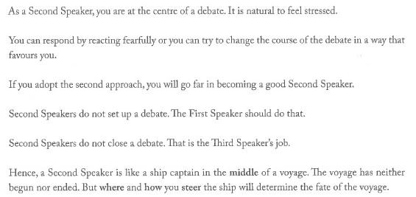
So what do second speakers actually do?

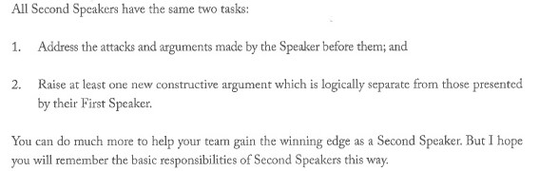
Why so?
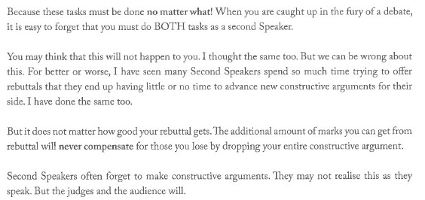
How do I make sure I sure do this?

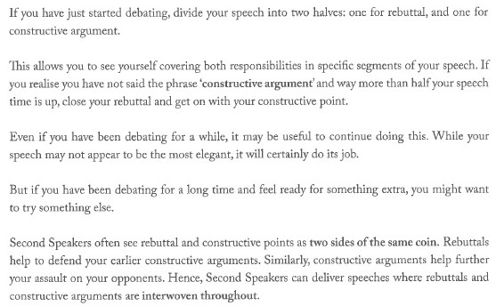
How do we build constructive points for Second Speakers?

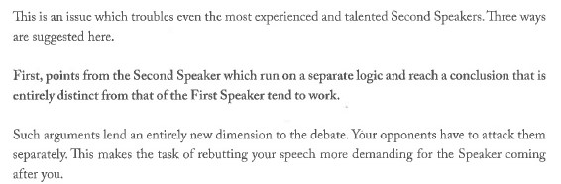
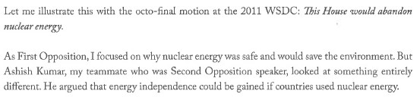



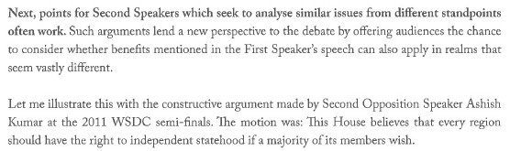
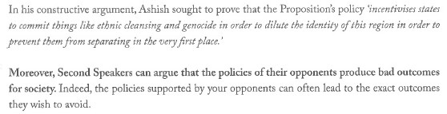
What is we can bring up more than one idea for the Second Speaker’s case?
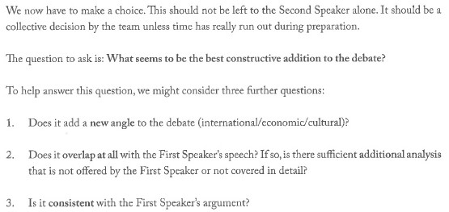
How do Iclose as a Second Speaker?
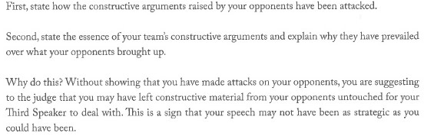

Thank you!

