
Part
11
BEING
A
THIRD
SPEAKER

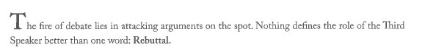

Why is this so?
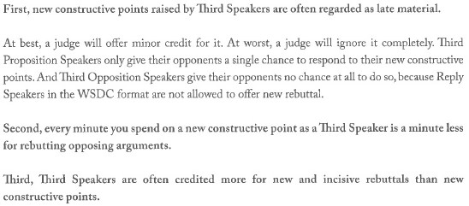
Why so?

What is a Third Speaker best poised to do?

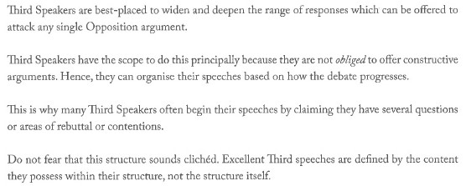
Are you sure about this?

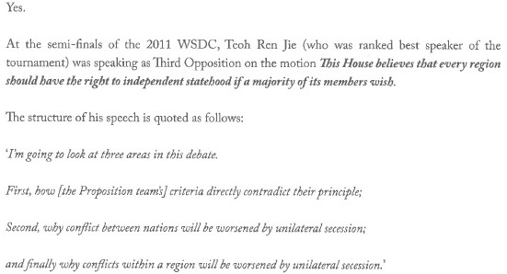
How can the rebuttal points of a Third Speaker sting?
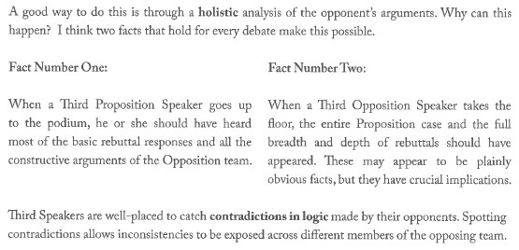
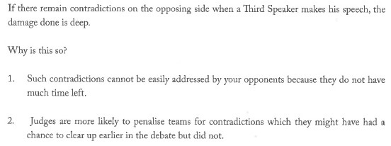

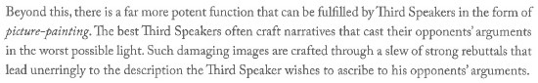
Counter-narratives in debate
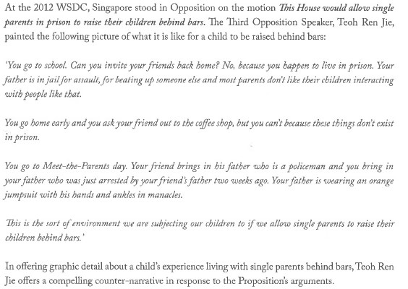

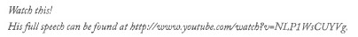
Do third speakers only attack their opponents?
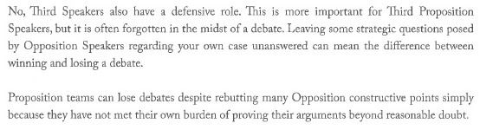
So there is a distinction between offensive and defensive rebuttals?
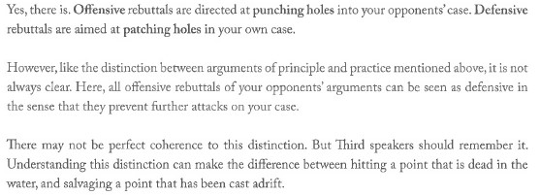
Can you please illustrate this?
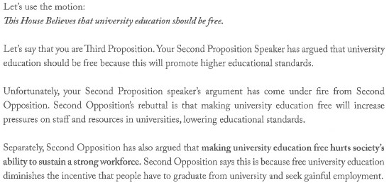
GUARD YOUR TURF BEFORE VENTURING OUTWARDS.
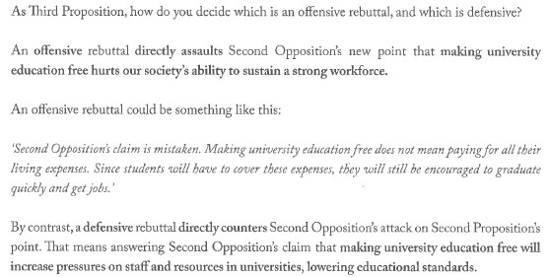
GUARD YOUR TURF BEFORE VENTURING OUTWARDS.
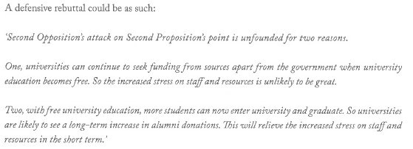
GUARD YOUR TURF BEFORE VENTURING OUTWARDS.
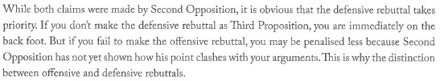
Let’s illustrate this poiny with a diagram
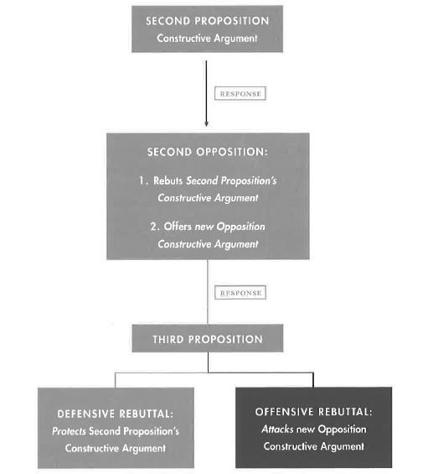
So Third Speakers have to attack and defend?
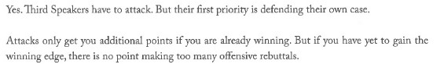
So Third Speakers have to attack and defend?

Thank you!

