Part 13

POINTS OF INFORMATION



In a nutshell

* Be sharp
* Be simple
* Be sustainable



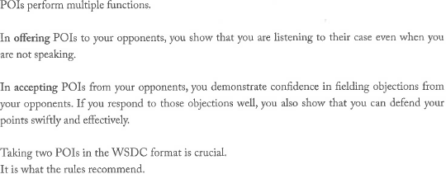

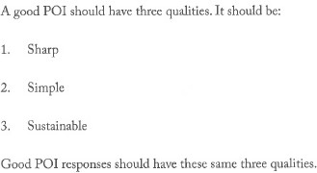

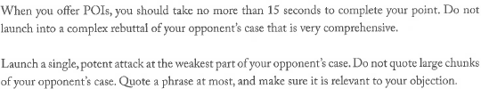

How does a sharp POI look?

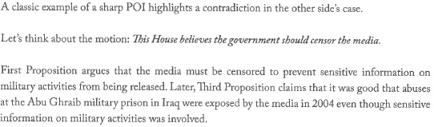

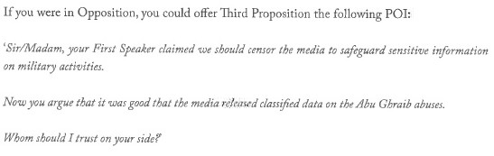

Why must a POI response be sharp?

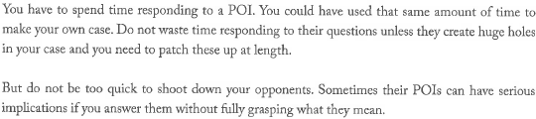

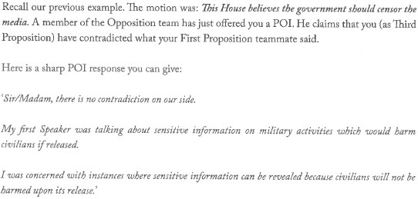

Why should POIs be simple?

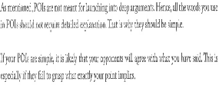

How does a simple POI look?

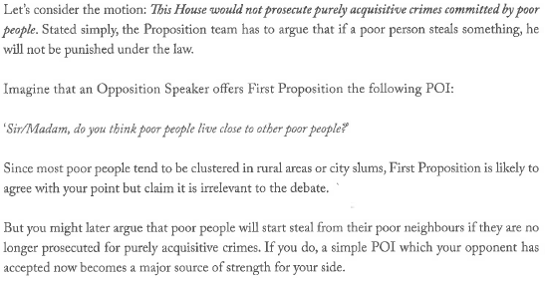

Why should POI responses be simple?



What is a simple POI response?

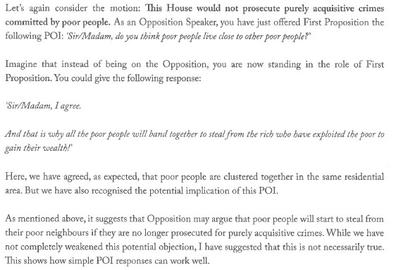

Why should POIs be sustainable?

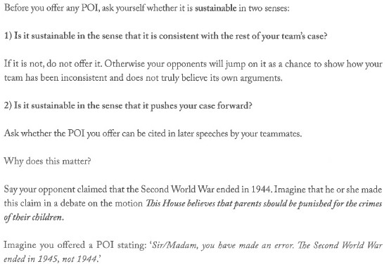

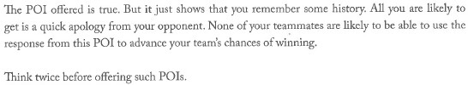



Why should POI responses be sustainable?

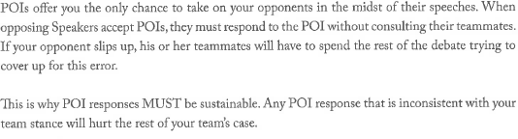



Thank you!