
Part
7
BEING
A
FIRST
SPEAKER

In a nutshell

• Set up your view of the debate clearly, • Articulate your team’s strongest arguments, • Attack your opponents where necessary

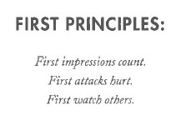
Why do first speakers matter?

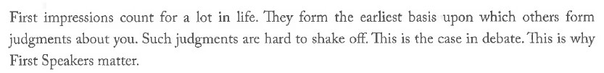
What do I do as a first speaker?
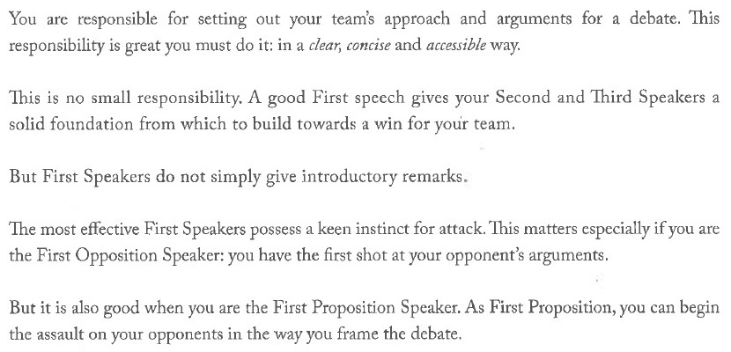
FRAMING: AN ILLUSTRATION

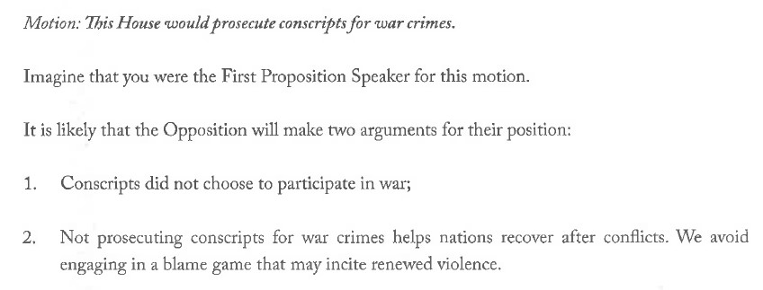

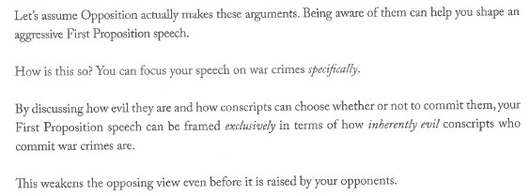

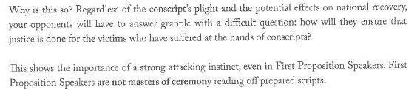
How do I become an attacking First Proposition Speaker?

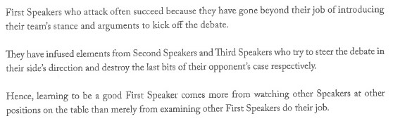

Thank you!

